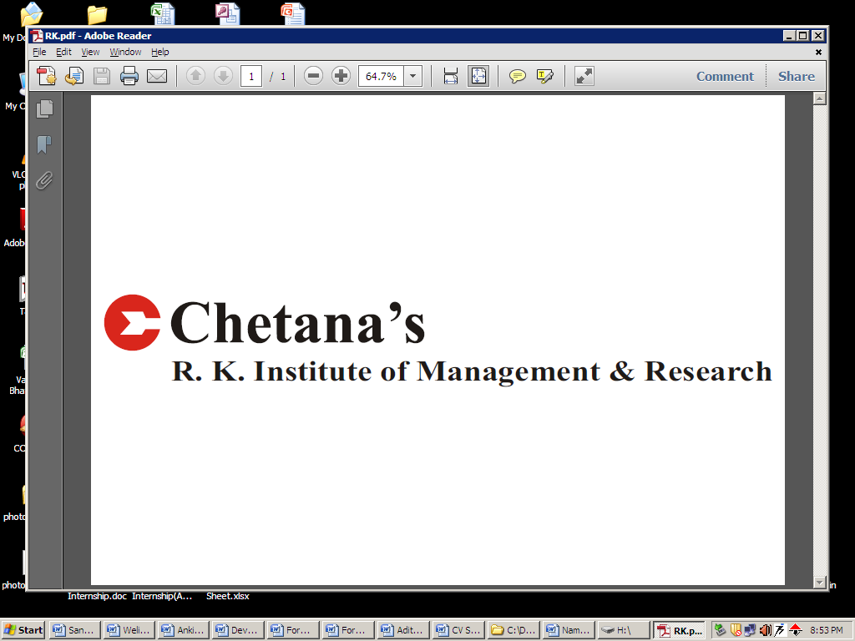
MATSAGAR DHEERAJ MADANRAO
9765527544
matsagardheeraj@gmail.com

MASTERS IN MANAGEMENT STUDIES SPECIALIZATION: FINANCE

EDUCATION QUALIFICATIONS:

Degree | Institute | Board/University | Percentage | Year
MMS SEM III | Chetana’s R.K. Institute of Management & Research,Mumbai | Mumbai | 76.09 | 2014
MMS YEAR I | Chetana’s R.K. Institute of Management & Research,Mumbai | Mumbai | 75.85 | 2013
B.E.(Mech.) | Maharashtra Institute Of Technology,Pune | Pune | 67.13 | 2010
HSC | K.T.H.M. College, Nashik | Maharashtra | 83.00 | 2006
SSC | Maratha High school, Nashik | Maharashtra | 87.06 | 2004

KEY ATTRIBUTES & SKILLS:

Adaptable, emphatetic, reliable,self-motivated,keen to take initiatives,cautious listener,effective at multi-tasking,technical expertise and efficient in written and verbal communication skill

SUMMER INTERNSHIP:

A Project on ‘A study of Wealth Management practices and opportunities available in India’completed at Birla Sunlife Wealth Management

KEY TASKS HANDLED: Analysed a case study on wealth management involving processes like
1.Risk profiling 2.Goal setting 3.Financial planning

KEY ACHIEVEMENTS: 1.Gained an insight into the area of ‘Wealth Management’
2.Accomplished sales target of two insurance policies within timeframe

OTHER PROJECTS:

- Completed a project on ‘Formulation of option strategies for RIL and SBI during August and September 2013’,in part completion of the subject ‘Derivatives and Risk management’

- Completed a project on ‘Performance evaluation of passive and active solar distillation system’, in part completion of Bachelor of Engineering during year 2009-2010

CSR AT CHETANA’S:

- FDA (Food and Drug Authority): This was an initiative undertaken to create awareness regarding benefits of registration under FDA amongst vendors and shopkeepers. The task assigned to me was to create this awareness amongst vendors and shopkeepers in Bandra East and Masjid Bander area.
- Jagruti: This was an initiative undertaken to create awareness regarding Gandhian Philosophy and Principles. The task assigned was to create this awareness by selling the autobiography of Mahatma Gandhi to corpoartes, institutions and individuals.

WORK EXPERIENCE:

Name of the Organization: Kalyani Charitable Trust’s Late G.N.Sapkal College of Engineering, Nashik

Duration: September 2011 to August 2012

Designation: Assistant Professor

Tasks handled /Role: 1.Taught Auto Cad and Basic Mechanical Engineering to first year engineering students
2.Conducted Fluid Mechanics and Heat Transfer Practicals of second and third year engineering students respectivly

EXTRA- CURRICULAR ACTIVITIES:

- Organised ‘Axlerate2009’ (college technical fest) in M.I.T.Pune, in Feb.2009

- Spearheaded ‘Discipline Committee’ of ‘Euphoria 2010’annual social gathering in M.I.T. Pune, in Feb 2010

ACHIEVEMENTS:

- Recipient of Late Mr.P.L.Mahajan Memorial Scholarship for scoring highest marks in aggregate of MMS-first year, first and second semester together(2012-2013)

- Received certificate for meritorious performance in ‘Hindi’ subject exam conducted by “Maharashtra Rashtrabhasha Sabha, Pune

PERSONAL DETAILS:

Date of Birth: 11th June 1988

Place of Birth: Nashik

Address: Plot no. 3, Choudhari Mala, Professor Colony, Near Bhavbandhan Mangal Karyalay,
Hanumanwadi, Panchavati, Nashik: 422003

Languages known: English, Hindi, Marathi

Hobbies and interests: Watching movies, Reading newspaper

